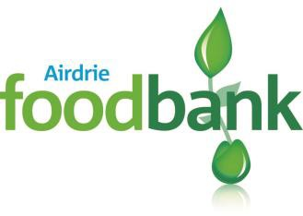
Role: Marketing & Fundraising Co-Ordinator (Volunteer)

Responsible to: Public Affairs & Funding Lead

Time commitment: From 3-6 hours per week or more depending on availability

Task Description:

The Role

To assist with the generation of income (food and financial) for the Foodbank through events and individual giving by:

- Developing new and imaginative fundraising activities, some of which may be events-based
- Raising awareness of the charity and its work, at both the local and national level
- Developing and coordinating web-based fundraising
- Working with all forms of media, and producing supporting materials such as posters, websites and online newsletters to promote, market and advertise forthcoming events
- Liaise with schools, businesses, churches and other community groups to maximise food donations and financial support.
- Regularly provide update reports to the Public Affairs & Funding Lead.
- Attend Monthly Steering Group meeting.
- Comply with Trussell Trust procedures & policies.

Skills/Experience

- Experience of fundraising, ideally within the charity sector
- Excellent written and oral communication skills
- Experienced in presenting information clearly and succinctly and good interpersonal skills
- Experienced in liaising effectively with a range of people at all levels
- A team player –working closely with other digital marketing team members
- Strong Project Management skills
- Understand Twitter, Facebook, YouTube for Business and have the ability to use social media to develop additional fund raising opportunities
- Empathy and understanding of the issues experienced by local people in crisis

To apply, download and complete application from
https://airdrie.foodbank.org.uk/wp-content/uploads/sites/67/2021/04/Airdrie-Volunteer-Application-Form-GDPR.docx and email to recruitment@airdrie.foodbank.org.uk

Airdrie Foodbank is facilitated by Calderbank Parish Church of Scotland : A registered charity in Scotland SC015831. Seeded by the Trussell Trust

